|  |
| --- |
| Close-up image showing the leaf-sides of two oversized books side-by-side on a bookshelf, with additional books in soft focus background |
| Unit 29: Application Program  Hashith Kaumina /CSD-70/1020433 |
| |  |  |  | | --- | --- | --- | | Hashith Kaumina /CSD-70/1020433 | 9/27/22 | PERSON | |

Contents

**LO1 Examine what an API is, the need for APIs and types of APIs.** 2

Application Program Interface 2

What is Application Program Interface (API)? 2

API us web APIs 4

What is REST API 5

What is SDK? 5

Explain potential security issues surrounding APIs 5

Parameters Attacks. 6

Identify attacks. 6

Man in the Middle (MTM) attackers. 6

LO2 Apply the knowledge of API research to design an application that incorporates relevant APIs for a 8

Firebase 8

Introduction 9

Using firebase my project 10

Facebook authentication 14

Twitter authentication 22

**LO4 Document the testing of the application, review and reflect on the APIs used** 27

black box and Whitebox testing 27

Test Plan - Channeling System 28

Test Case – Channeling System 29

**Test Case 1** 29

**Test Case 2** 30

Critically evaluate the APIs used within application. Provide a data security report of application. 33

References 34

# **LO1 Examine what an API is, the need for APIs and types of APIs.**

# Application Program Interface (API)

This is a user interface and it’s an interface of the software. Application program interface software is used by software applications and this is like interface as apps and other software which are used by men. The sundered electrical socket can be found in walls like a metaphor to explain the instructions of APIs. It should be there to have a standard. (Berlid, Dec 03, 2015)

# What is Application Program Interface (API)?

APIs are known as Application program interfaces. This can be used to interact between two applications and there are some rules to use when interaction among the application needs to access data of other applications. Which is mentioned application when one application rejects to supply service to another application. Then ready for another application then ready to start working awesome apps. When need to start at rapid. APIs marketplace then the APIs supply interaction among one software and another even though it does not need users. Even though when it supplies interactions an application can get the user interface widget and show it so that APIs are highly beneficial. As it helps to do standardization as well as a simplification which the data for the user. As an example. If bloggers put their Twitter handle on their bog’s sidebar, WordPress can work with this using Twitter API. Major sample of web APIs and there are four main APIs. Open APIs (Anon., 2020)

* APIs is defined as public API. This type of API cannot be restricted to access. So, this kind of API is a publicly available partner.
* If this API need to be accessed there should be specific rejects or licenses in case, they are not allowed to be able to be public.
* Internal APIs: - These kinds of APIs define as private APIs. Private APIs are absorbable internal systems so these kinds of APIs are not so familiar and are mostly used inside the company.
* In order to improve the company service and productivity most companies are using these APIs.
* Composite APIs: - this API is used to joiner various data and services.
* There are many more tasks which run synch ruinously as a result of the execution but it doesn’t request the task.

API mostly used to speed up the process of execution as well as to accelerate the

Performance of listeners in the web interface. Browse APIs web service APIs is not associate with web API is not associate with web APIs and the web service APIs. So, XML-RPC JSON-RPC-REST. A web service can be defined as a system or software which can be used an address. As an example, URL on the w.w.w. to supply access to its services.

There are some common web services

* APIs: - SCAP (Simple object Access protocol)
* ACAP is a kind of a protocol which can be used in XML to format transfers data.
* This is used to structure of messages and communication method.
* SCAP can be used as WEDL or web service it can be read able document to publish.
* This protocol can be used as specific XML and format the data which compared to SOAP and that can be used to proprietary XML format.
* This also introduced before SOAP, XML, and RPC. I t is easier than SOAP. As an example, Becky smith JSON RPC.
* This protocol is alike as XML RPC Even though not Even though not using XML format to transfer data. It uses JSON. As an example.

{[“Employees”]}

{“First name”,”Beckley”,” Last Name”, “smith”}. REST.

(Representational state transfer.)

REST isn’t a protocol such as the other web services. According it is like an arch textual principle.

The REST service expects some characteristics. Which has simple inter faces that can be recognized easily. When it asks and manipulate of resources using the interface of resources using the interface to obtain API need to add our API Market place.

Add the API to the marketplaces what are the varieties of among SCAP and REST.? SOAP REST have to use vales and highly protected security system to follow.

There are some easy guidelines

It has function based system.

Need to data to drive and it needs more band width.

It needs limited bandwidth different among JSON and XML? These are supported only text and numbers.

Support different type of data. As an example, image, graphs, text, corseted aimed only for data.

When interfaces work, they supply their benefits and to the customers. Like develop, mobile, web and sever side application. They are not different from other electrical sockets as well as the profits which they supply to the customers. Like computers and appliances. As an examples if consumer device may outsource its.

Electricity services is a wall socket interface. A used application can outsource its needed for data like record of patient or some time location appliers as pinon an interactive map.

If the API provide has named as considering applications and service. There can decoupled to the point. But they do not other one or know tittle the interfaces which they communicate paper as an agreement on stand ordered which applications to make needs of the service and have data and or functions in return. When one API to the next is known as set of agreed on standard; contract.

API can be used as interface which helps software programs interface with each other. When its program used has one another. This also shows how the rout lines data structures as well as it shows how the application communications. API has different functionalities. The library functions provided by the general APIs of programming languages like Java API. There are Google Map API also and language indigent when use APIs should implement carefully some API for functionality or data to the outside API is very population usage in internet APIs appear in different shapes and sizes. Its browser can be used for converting user commands in to usable functions. Request data form services and render that data in to viewable format to the user as well as validate the performants according to the users request.

It can be easily copping and pasting on a computer tool in API the coping text can have a key stroke in to a command data which is store in to RAM of the APIs utilize clipboard then data is caried among the two applications using same API. After that data is rendered pasting with the help of another API.

On the world wide web, API associated with the various functions. The web API helps to interact among disparate systems. As an example. If a user interacts on Twitter. The use APIs to comment to store the given data to user a user to delete tweets. The web API has set of instructions as the personal computer API even though with the web service but sometimes API allow for consistency which is the very important fact in APIs. In the past the programming of computer was wild web to of components and instructions loosely coded and rarely documented. But new computing APIs have many options and cording in in stable environment which helps in replicable functions. As well as requesters is submitted in success fully web services API.

Instead of main web APIs there are some other web service APIs.

* SAP
* ZML-RPC
* JSON- RPC
* REST

Web services are not only software but also a system which use an address. As an example, URL on the world wild web to supply access to the services.

Given below are the common types of web service APIs.

* SOAP stands for simple object Access protocol. This SOAP used as method of communication and structure of messages and this also use for web series definition Language in a machine-readable document to publish known as its interface.
* XML-RPC – this is known as a protocol as a specific XML used for transferring data compared to SOAP that uses a prepare eatery XML format comparing XML is older than SOAP this work with least bandwidth as well as very simple.
* JOSN-RPC-This also a protocol but this is smaller than XML-RPC-This protocol is used to transfer as for mat data as XML-RPC.
* REST: - This is stained for representational state transfer and this is not a protocol. This service requests some characteristics. This can easily identify simple interface and can manipulate resources using the interface.

### API us web APIs

There are some considering words in the whorled of web. But we hear them and pass. Because we need not to wrap our head with them and they have web API, REST API, and SOAP API with others. When we need find some words. Which confused so then read through in order to understand their meaning also and related differences also.

## What is REST API

This is known as kind of an architectural style of web service which is supply a chance of communication among computers or system. So that the REST API is an application program interface as well as it is back by the architectural style of REST. As an architectural principle it needs tools, service or software, this can be used in any protocol also. There are some advantages of REST API is providing more flexibility as well as data is not considered to resources. So that it can be used for various types of formatting data.

## Advantages of API

* If we have knowledge of about the benefits of API production easy to copy with system owners and other users to develop their agency’s systems and unlock there are some benefits of APIs.
* API access can be used for create once and automatically publish or there can be easy to, many channels. There our agency’s contact be able to share and redistribute to supply on mission to vast variety of citizens directly.
* if someone need to create a new presentation layer web site a widget or app. API must be used to deliver services and information to new audiences and be tolerate the user experiences also when user do not come to our web. When a user does not come to our web site can be able to get agency information or services not only app but also website which are normally visit.
* the federal government product the data and information are a natural asset. As well as API can be able to get data which was available to few and it can be make available for everyone.
* If there is good quality and complexity of APIs. But there is a security gap. Such as other facts of cyber security. The project may have lot of work as adding fire walls segmentation vulnerability and other if the API can be inbreeding then the attacker could evade Many security measures.

### What is SDK?

This is known as set of rules which can be used to develop software applications on specific platform SDKS has tools, libraries, documentation, sample code. They help the programmer to develop their application’s. Some interface can be downloaded SDKs. BDK Program language is free to be used for programmers. SDK languages like Java SDK (JDK) which has all the libraries debugging users that helps write programs. It is very easy using Java. The software developers can easily use SDK. Not using components or tool which are compatible easy to install.

API is help to interfaces software programs to work with each other. The But SDK is a set of tools which can be used as software development application the easiest version is SDK is API because it includes some files which can interact with specific programming language simple SDK has API also not hovering debugging support.

When consider the API is set of building blocks which helps to create something the SDK is a full-fledged workshop helps to create outside the aims of what an API world be help.

SDKs is used by the modern users because it is an organizational. Sources for most program. Form the web browser when we play with video games until the end of the day it may be a first bult with SDK but API was used before to communicate with other applications.

## Explain potential security issues surrounding APIs

Most businesses find digital information for path to make more money expositing their data to out siders via apps such as website. And other third-party integrations. The selected API as their major IT security risk. And this is mush rooming security risk. Because they provide a venue for hackers to try to hack company data warned terry Ray as a chief security close the door when comes security risk as well as protect their customers. API as a protect tor they supplied its web applications.

The API use as source of risk posed Scott Morrison mentioned about API security. The weak point of the API is they affine supplies road map exclaiming the underlined implementation of an application. So he said that IT is a chance for the attackers to overlook. API provide clear and self-documenting best as well as province insight in to internal objects and internal data base structure like impatience valuable for attackers. According to Morrison there are some ways of exploit access data or computing interfaces structure such as.

### Parameters Attacks.

This is happened when submitting unexpected data to drag weak basses in application and database. SQL injection attack is the most common parameters attack. it is very useful when the developer’s do not clear inputs. Morison explains that contrast to many webs’ apps API have proper understanding about parameters understanding about parameters unclearing usage of their name it is easier to understand the attacker’s job.

## Identify attacks.

API key is a code that single app which is used for identifying them to an API which meant developers secret and concealed even though. It is easy to uncover them which means APIs authorities are at risk. So that others have API can use them to write code of others legitimate application.

## Man in the Middle (MTM) attackers.

These attacks may be happened when the attackers sits among API and application user intercepting the traffic among two both impersonating each other. Some APIs need not to use SSL/TLS Properly.

#### Lack of TLS/ SSL

The first step of the secret APIs is encrypting at the transport layer. If it is not using a suitable transport layer. It is not using a suitable transport security an eaves draper can read and temper the data. Which means the man in the middle attack?

#### Encryptions does not imply trust.

When encryption communications to communicate the result of wobbliest it need SSL certificate that should be validated. When exploited vulnerability can hacks to use fake certificates and traffic interception utilize to get user name, password, API keys and most important user data also.

#### What is SOAP API?

SOAP is stand for simple access protocol. This is very powerful communication protocol system and massaging system. It helps to processes various tools of operating systems like windows and Linux to communicative it HTTP, and XML – SOAP APIs and they can create, updates, deletes record and record like passwords accounts, customer objects and ideas. When web API in the time of web services not in web w.0 tern SOAP shows REST style web resources.

#### SOAP and XML

SAOP can be used for massaging protocol which is XML. Which underling data format. The disadvantage of SOAP is it gets more line to tools log as well as it is with complex data layer XML as encryption issues external entity attacks as well as SOAP takes long time to provide protection because there are lot of system depends on it and there are not so hard investigatory the security implications.

#### Business Logic flows

In official API designable to supply access to a subset of end points. As an example, data is trying to touch in specific way It is the reason which deter of APIs. To make the boundaries. Attacker try to find out other solution and calls to get data outside of the boundaries and they try to do this exploiting business Logic flaws in the design API. There are some captured victims to business logic flows attacks like Facebook, video and Nokia.

#### Insecure end points.

Always API end points careful about security stand point. If they protect for long time after the development the developers as well as sysadmins less consider to tinker for fear to break latency system depends on APIs. The end point hardening measures like key signing hashes shared secrets sue that it can it can easily incorporate with the previous level of API Development.

To cover range of uses evaluate the ranges of APIs in a particular plat form changing the customer data how the business a operates. When correctly gathered and shitted. The company can be shood up the customer retention rate and leading really burst in come even though data crunching is different. So that business required computer science in 1990s. the database which helped to automate plenty of time use a data task is more popular among marketing departments. This allows to big shift in how the marketing strategies were very easy to shift. It is known as data driven approach.

Databases had a main con through. Make them something very important a company wanted to hire software engineers. They are considering as hero’s because they are the person who know huge piles of data converted working insights. They also considered as data guaiol protecting integrity as well as make sure their system was future proof.

Even though cost of software engineering is very high and it is affecting their communication interface. If the large number of channels of data collections make to large over number of departments and external companies’ databases and their operation become very hard. Businesses are searching out an automated path of accessing data stores. API the basic systems. Now a days shortened as API. That is the application which can be rely on that other system they can access their data security way. If there is no grade of computer science the API doesn’t even ring the bell API used for evolving need every API management platform to supply a need able capabilities like API creation. Integration and management As API management platform is required to supply capabilities like advantage routing and transportation.IT is the domain of APIs. Development and integration.

About TIBCO- this software is used business for their digital proposed introducing all the things in correct time and suppling an argument a knowledge for all from business users to data scientists. This both relationship supplies spec by answers. Very good diction as well as very actions. During 20 years more than thousands of businesses over the world trust on TIBCO Technology for various purposes.

# LO2 Apply the knowledge of API research to design an application that incorporates relevant APIs

application relevant APIs

Research and evaluate alternative API similar to proposed system and enhance the system design.

Firebase is a new app which is in global markets. If was introduced in 2012. This has special features like real time synchronization. This is very profitable in business which need zero latency in data computing and analyzing. This can be provided build in support for third party apps. So, we used firebase it can be stored database API have various benefits. Such as it can be store easily and it is also an open source.

We used API as our authentication as an example Google sing API, Facebook sing, twitter sing API, there are many benefits in authentication APIs. Because it is very safety and user can access very easily and user can save the time to take for typing password and e-mal.

Using an API first reach defines as adaptability and not considered as what development projects. API language is applied to describe the language like open API if our API is key and it help to perform a contact. How our API communicate among other programs. But the language behind it cannot be known. API is not exit in a vacuum it is very important that collaborating and planning. Before write any code should log. When use the API first stagey need to think about very fast and understand the design process.

In the past the software design process strafes a problem can be identify and the program can supply the suitable solution. When the broad strokes are stablished any system. They all consider of user experiences so that having a system which dotes work properly. It requires user friendly developer and customer to interact of with it. It may be with front end or back end. When there is a simple problem, we can accept internal application with data. Which we required to make accessible to other system. Through API. This system had an own logic which form its interaction and behavior our with others so can see any API can create idiosyncrasies and constraints. When our internal application is joined with an API then developers interact and capture with it rely on the system’s. internal structure. When we need to make chances lately in the internal model there may be some issues. Designing an API first approach known as building an API is more than a byproduct an API is more than a byproduct of an internal system of APIs. Supply a specific structure for convey sing message among systems. API implementation isn’t. IT issues. API expect is organizational goals and objective API strategy is at the fore front of the design process.

The API first approach has powerful effect on consumptions of API. if our organization has high goals and adaption and retention rate or suppling a powerful experience of developer. The most valuable API design supply a seamless users experience can be understand easily resources and value. It can be done quick in tarnation and usage can mention that APIs are more responsibility, continued and more enjoy the developers.

## Firebase

Firebase is a main tool which helps to expand the business very faster by using this app cloud and mobile is gone by everything. So that this app is needed to strategy to reach a very big audiences and to increase the sales. if there are some challenges to develop and an app. It is being regularly store the data security with real time sync. And have to fixed the by very quickly. This is used to analyst the apps data for highly in to our project performance when we use very powerful. Platform as firebase can full fill above performances.

As well as this is very good solution of google and we can get this as successful apps. This also help us to supply real time database sync the data and stored safety. Among real time and users. If we use firebase REST APIs it is very easy to load and query data from database flowing of data to and for from the firebase data base is very fast and smooth. For mobile APIs it is very effective firebase REST APIs like live streaming and chat massages etc.

This is an app which can be used for one-stop solution of developing and maintaining of developing and maintaining as well as expand the business growth. As a development app it processes this Backend as a service. (Baas) help us to create and run IOS, Android web Apps. As an app development and testing and analyzing the app performance and joined with the audience. Firebase also supply the set of tools of diverse can be handled smoothly above tasks.

Firebase like firebase database let our data sync and store the data in a real. Time NOSQL data base program in JOSN. As documents among. The users by using looks like firebase crash Analytics and Google Analytics. By using real-time analysis can lead the performance and stability of the app continuously thoroughly the rash analytics can assist in optimizing the apps for the very good experiences and also allow to AB testing and messaging campaigns. By using open sources code as can automate general develop mint tasks. Testing features. With the help of user experience can developers to see lot of enhancement.

Key features of firebase.

Real time database: - this is supplied a real time NOSQL Database hosted on cloud. The client can be reflecting for the others when there are any changes. The connected client helps the user to get real-time data form where he or she wish and any time and any audience. This is eliminated any service needers suppling mobile and web SDKs for building the apps. And can work offices if the data can work offline if the data is stored in local cache. The it a will be synced to the database automatically. When we need to come back online.

# LO3 Implement an application in a suitable development environment

# Using firebase my project

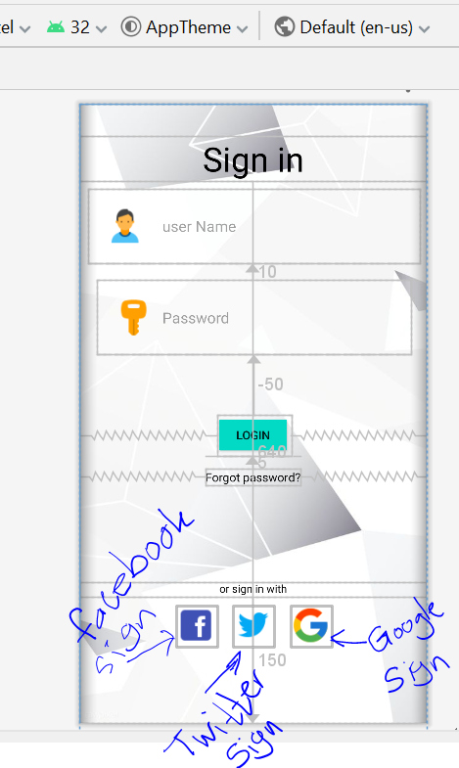

1 step: - in android studio click tool / click firebase

2 steps: - click authentication and click authentication using face google login. Click connect to firebase

3 steps: - Go to google services make the project. Next go to the website start integrated Google sign.

Next go to google services after that add the dependency and add copy this and past it in Gradle scripts. Build grade (Module my login)

4 steps: - Go to the Main Activity and type the According to the blow picture Follow the steps given in the below pictures.

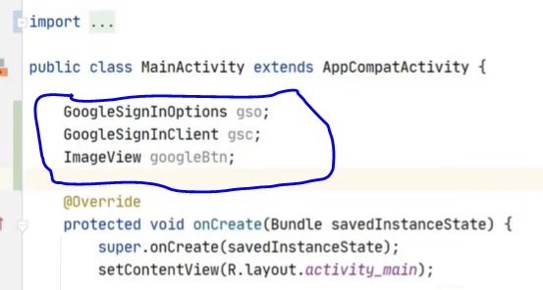

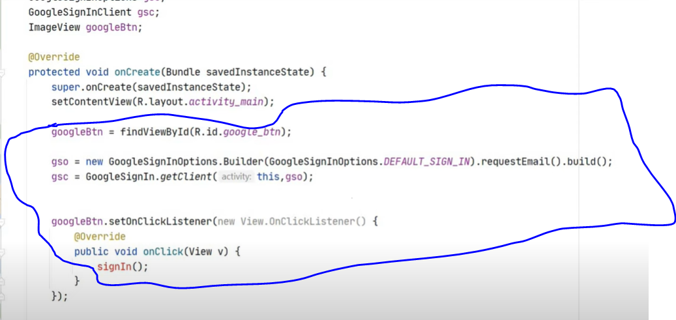

5 Steps: - set the google account forth maximum 1000.

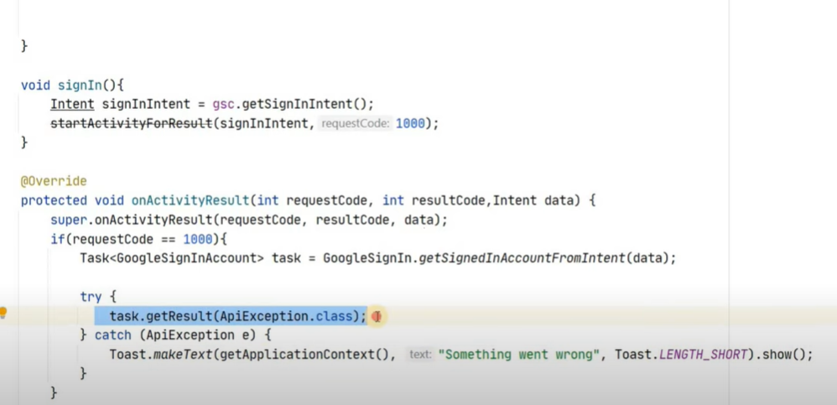

6 steps: - Navigate next page.

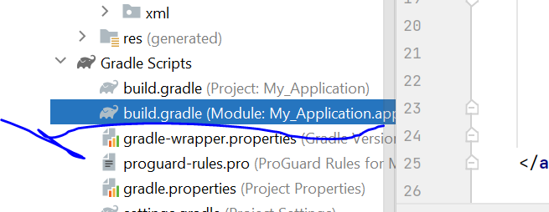

7 steps: - configure project.

8 steps: - create project name and click Next button.

9 steps: - Give the product Name. click the Next button After that select Android.

10 steps: - Go to the Android Application and go to Android manifest copy the package name and past to the package name.

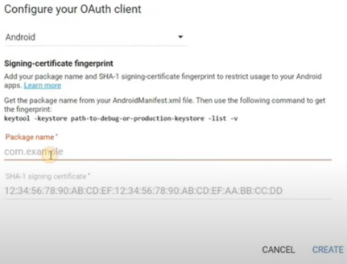

Go to the Gradle and go to the build tool setting select the Gradle setting. Click the Don’t build task list during Gradle sync and click apply.

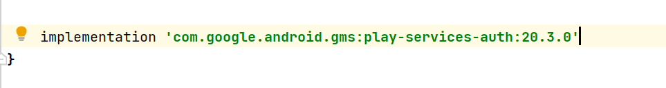

11 steps: - Open task go to sign in Report and go to sha1 and copy code and past us configure Authentication website and past sha1.

12 steps: - click the ok button.

# Facebook authentication

Step 1

Code the android studio

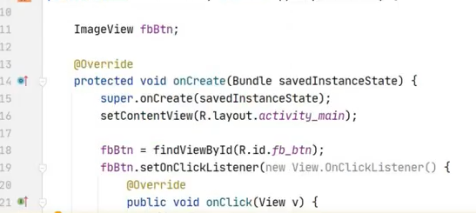

Step 2

Open <https://www.facebook.com/docs/facebook-login/android/>

Make the Facebook account. Create for developer account

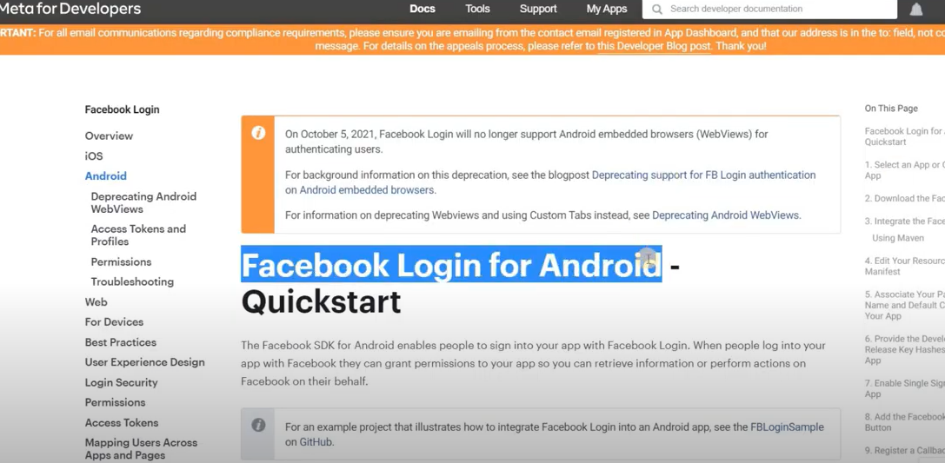

Step 3

Go to the Create new append add project name. Given the email and face book pass word after that submit.

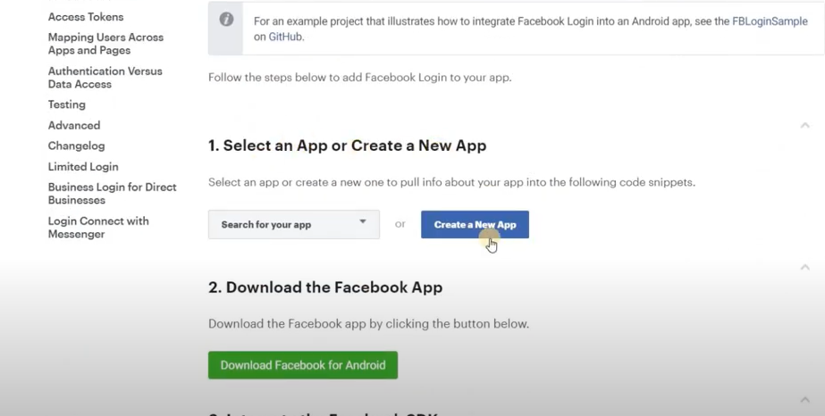

Step 4

Like

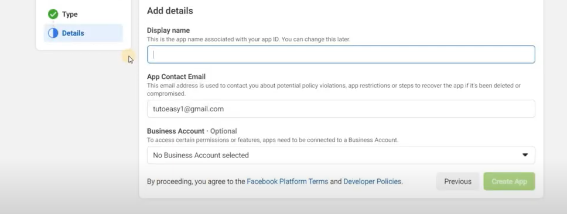

Step 4 Like the Facebook login icon

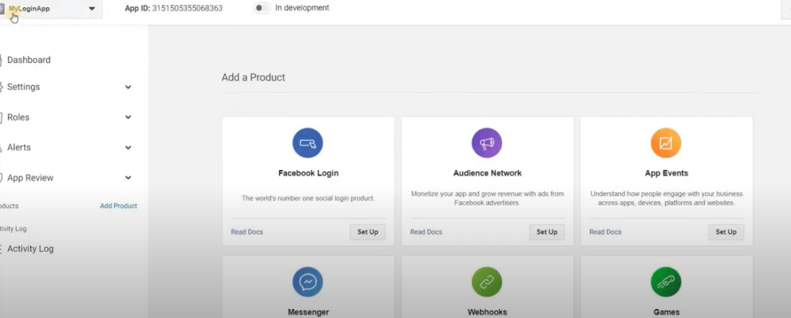

select the android Facebook

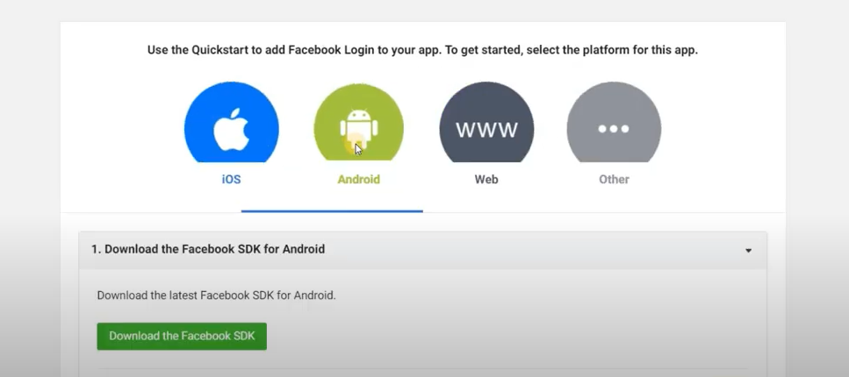

Step 5 import the factbook SDK.

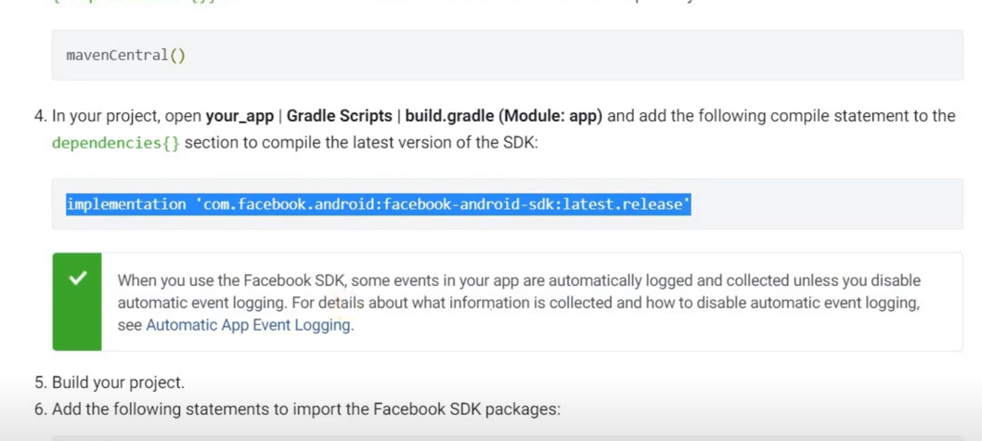

Step:-6

Go to the android studio and go to buidgrdel in the dependencies. Go to the facebook developer website and click the next of dependancces given the project name and defolt activie class name.

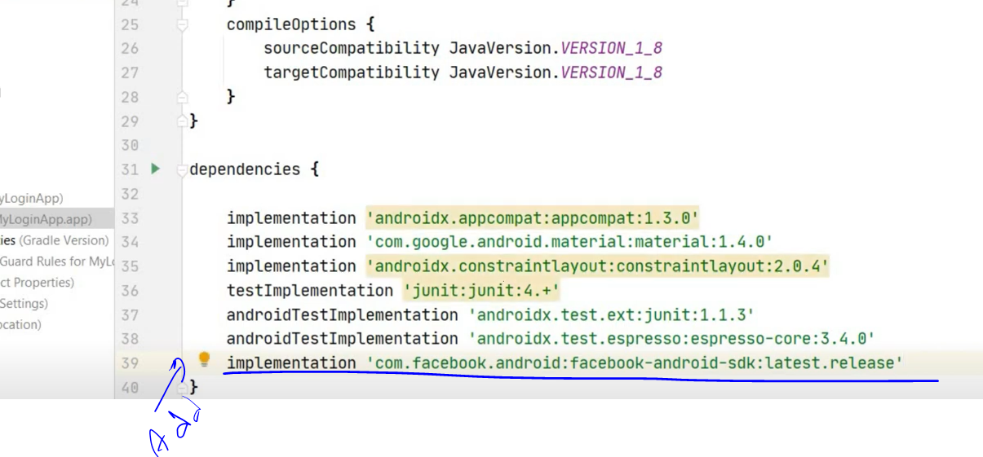

7 step- Go to android studio manifest and copy this package name and past in the Facebook developer package name and default activity class name.

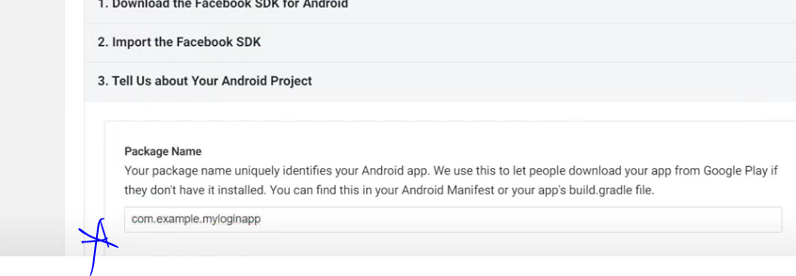

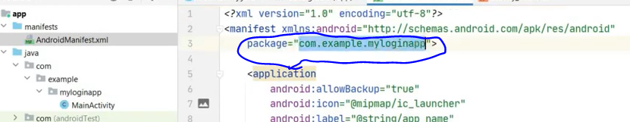

Step 8

Select the add you are development and release key hashes copy the windows command.

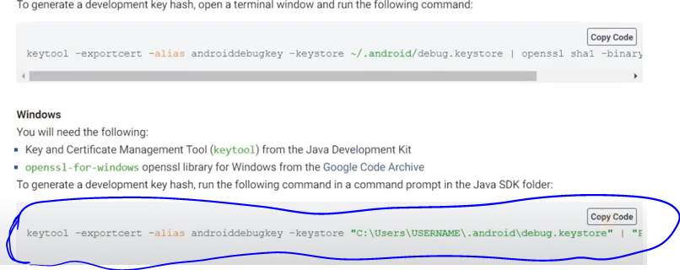



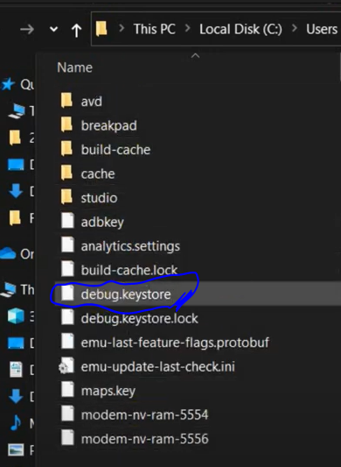

Click the Google code archive

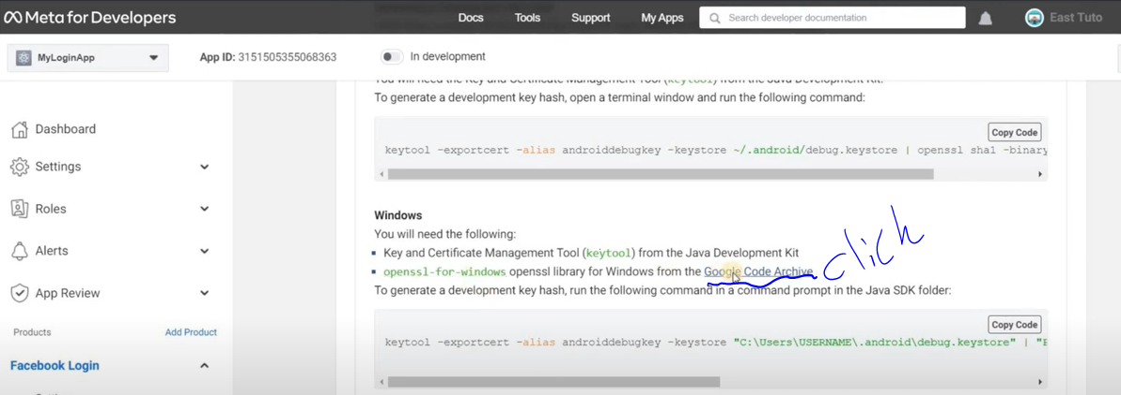

Go to open SSL and download open SSL and downloaded open SSL and download suitable file given the path and to open library and given the path to open library and given the path we have copied.

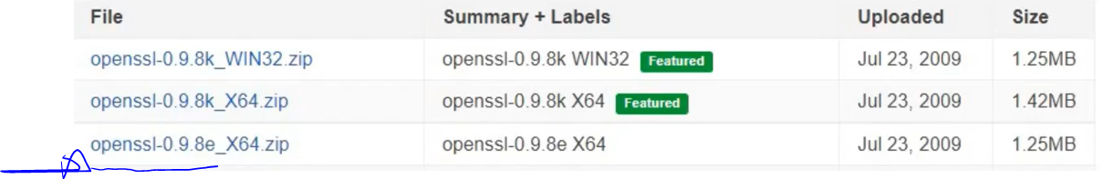

Step 10

This PC>local disc(c) >program file> Java >JDK16.01>bin> open CMD and past the previous code given enter and password.

Generate the key.

Copy generate key



Step 11. In the Facebook developer and past the key hashes

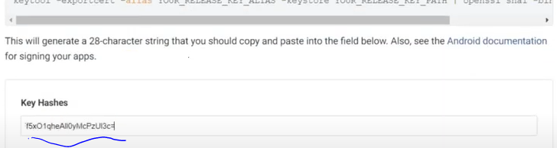

12 steps

Copy the code and past the android strings copy the to.

In the Facebook developer website has to add Facebook login button and copy the code in it and past in the android studio.

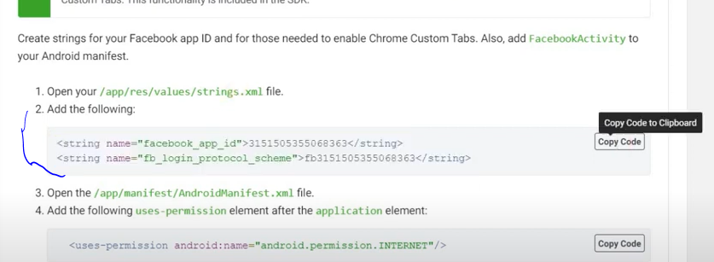

In Android studio go to its main activity and past the code

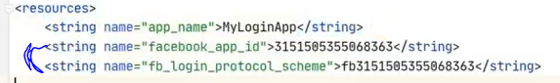

Copy the code Facebook developer website mentioned and past to the android studio as given below.

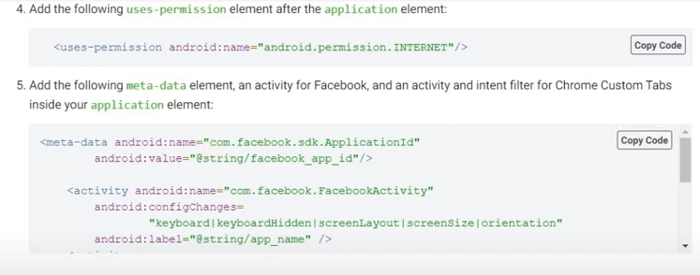

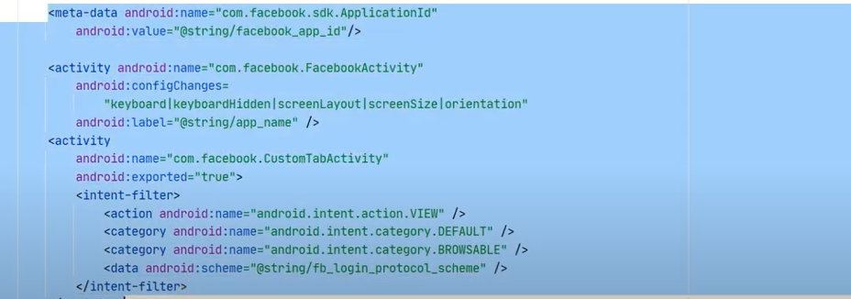

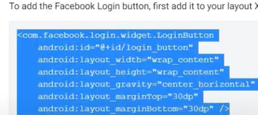



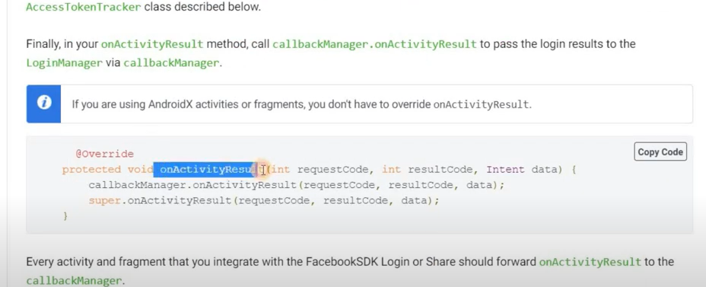

Step 15

Click the Facebook icon which we made after that load our Facebook login successfully.

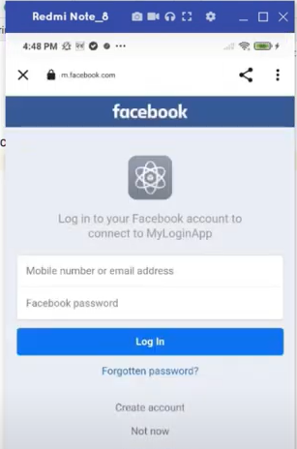

# Twitter authentication

Step 1

Open <https://developer.twitter.com/en>

Make the Twitter account. Create for developer account

Step 2

Click the exploring API verify the account.

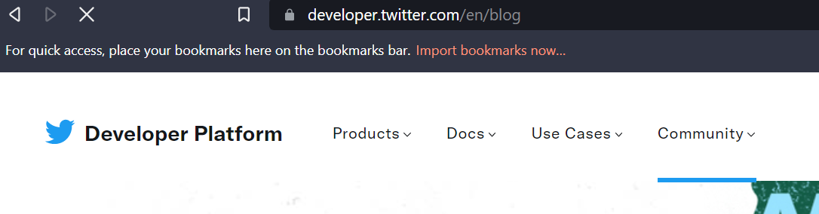

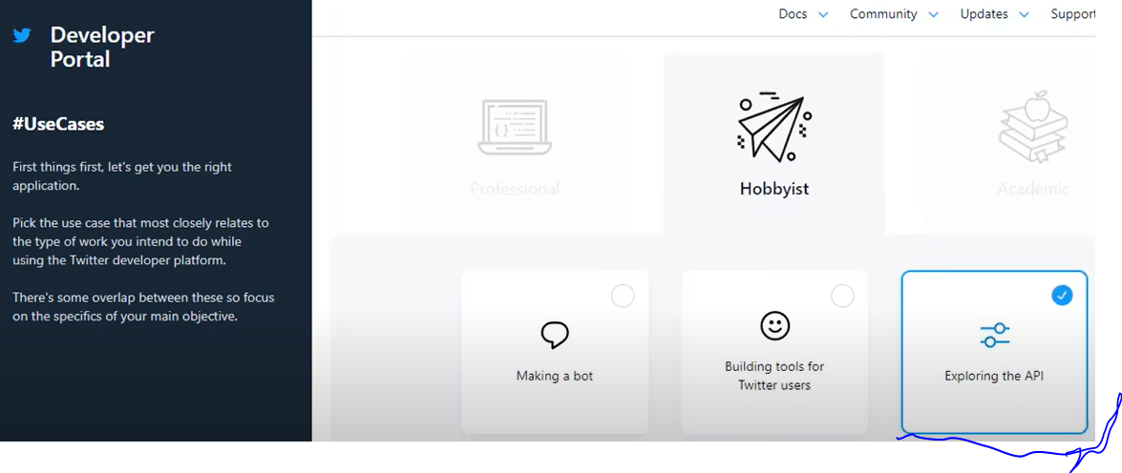

Step 4

go to Twitter developer account and go to the authentication setting.

Allow the cnable three legend

Step 5

Go to the firebase my project and go to the authentication

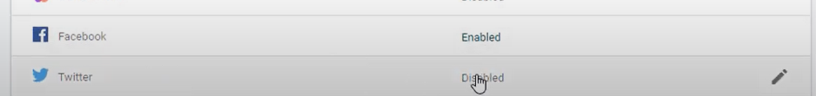

tab enable Twitter copy this link



Step 6

Past the twitter developer website and past call back URL.

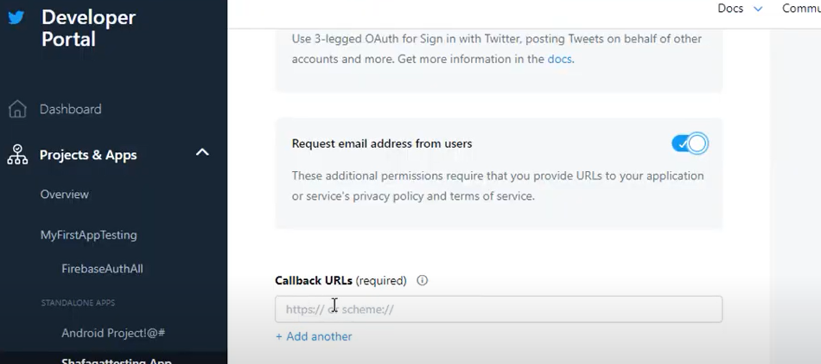

Step 7

Go to Twitter developer and go on to consumer key , API key and secreta it and click on API key generate button.

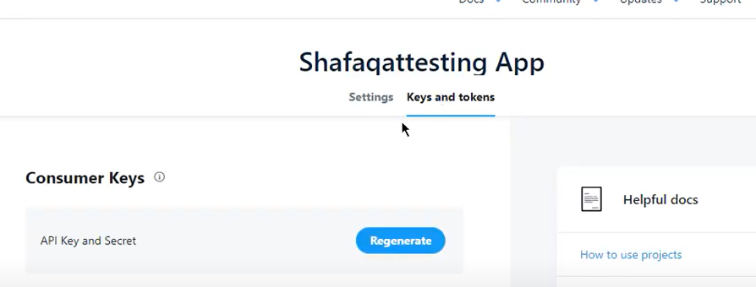

The generate key is given below picture

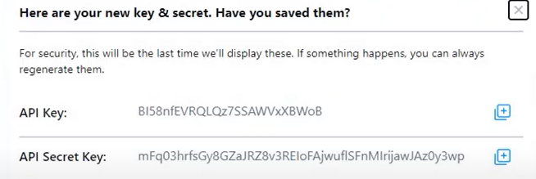

Step 9

Go to the website firebase authentication. After that select the twitters connecting after select the Twitter

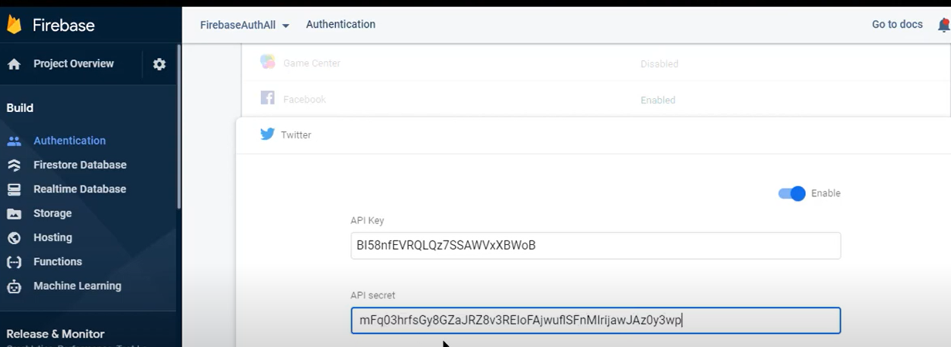

Step 10

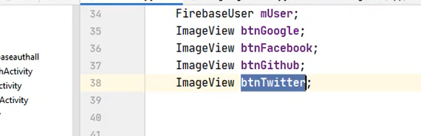





Step 11

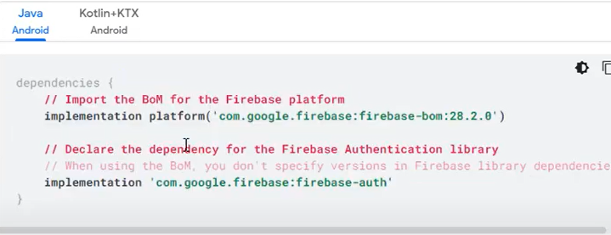

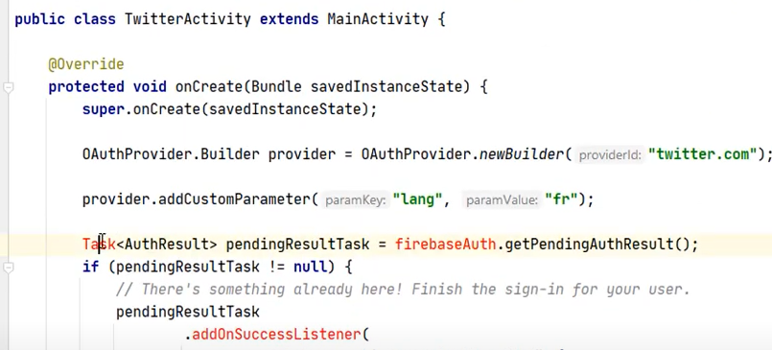

12 steps

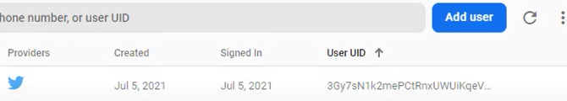

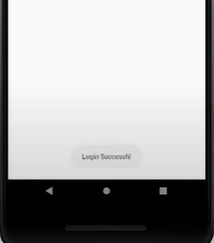

# **LO4 Document the testing of the application, review and reflect on the APIs used**

## black box and Whitebox testing

The black box and Whitebox testing methods used for developing the system testing.In the current system there are some mentions to test. such as testing and security testing system testing. Such as testing and security testing, system testing, unit testing. These meth ends are chosen on behalf of involving testing the whole system for bugs and errors.

During the unit testing phrase. All the part of the software is tested for errors. As same as follow the whole system is tested after integrating the whole system because make sure to that after joining all utilizes works. When the is phase the security testing is being done. After fully testing that is ensure with all fully that is encrypting with all vulnerabilities or loop holes are fixed before releasing system as an example for unit testing. There is an example of white box testing but inside have to be known that inside working this system so that system developers normally using is system testing. By using this testing system, the user doesn’t need to know how to operate that benefit testing it next the security testing is a prime example of gray Box testing. This testing method can be joined with white box testing and black box listing black box system is needed to test implementation of target system.

* The user should be able to login / register to the app.

Status: **Pass**

* The user should be able to google sign / register to the app.

Status: **Pass**

* The user should be able to Facebook sign / register to the app.

Status: **Pass**

* The user should be able to Twitter sign / register to the app.

Status: **Pass**

* The user should be able to select books of the category.

Status: **Pass**

* The user should be able to select books and read them.

Status: **Pass**

## Test Plan - Channeling System

|  |  |  |  |
| --- | --- | --- | --- |
| **Test Cases** | **Test Case Name** | **Scenario** | **Expected Results** |
| **TC 1** | Login | Testing the login page and ensuring it works as planned | Comparing the username and password entered by the user against the pre-set values, and produce a message if the username and passwords match.  Produce error messages when an incorrect username or password is entered.  Direct the user to the registration form if the login credentials match. |
| **TC 2** | Registration Form | Testing the page where the registers a user’s | The system should check and validate each form before adding the data to the firebase. |
| **TC 3** | Main Form | Ensuring the main page works as expected. | The system should include all the books and Specialties from the database in their respective search categories’.  The system should accurately fill the search results panel according to the user’s search criteria.  The system should check and category the form before going to the books. |
| **TC 4** | Books Form | the book list form to ensure it. | The book is selected by the user.  The system should accurately display the available automated books watch time and the token number. |
| **TC 5** | Librarian | Checking if the Books Status user connection works as expected. | Librarian should include all the books Name and their corresponding ID in the search Category.  Librarian should automatically show the selected user’s books status. |

# Test Case – Channeling System

## Test Case 1

|  |  |
| --- | --- |
| **Test Case ID** | **TC 1.1** |
| **Test Objective** | Direct the user to the registration form if the login credentials match. |
| **Test Data** | **Email address– ‘hashithkaumina99@gmail.com’ Password – ‘pass#word1’** |
| **Expected Result** | user gets access to the system |
| **Actual Result** | Success |

|  |  |
| --- | --- |
| **Test Case ID** | **TC 1.2** |
| **Test Objective** | Users error messages when an incorrect username or password is entered. |
| **Test Data** | **Username – ‘user’ Password – ‘pass’** |
| **Expected Result** |  |
| **Actual Result** | Successful |
|  |  |
| **Test Case ID** | **TC 1.3** |
| **Test Objective** | Direct the user to the access to the system if the login Facebook authentication |
| **Test Data** | Lording Facebook authentication |
| **Expected Result** | user gets access to the system |
| **Actual Result** | Success |
|  |  |
| **Test Case ID** | **TC 1.4** |
| **Test Objective** | Direct the user to the access to the system if the login Google authentication |
| **Test Data** | **Email address– ‘hashithkaumina99@gmail.com’** |
| **Expected Result** | user gets access to the system |
| **Actual Result** | Success |
|  |  |
| **Test Case ID** | **TC 1.3** |
| **Test Objective** | Direct the user to the access to the system if the login Twitter authentication |
| **Test Data** | Lording Twitter authentication |
| **Expected Result** | user gets access to the system |
| **Actual Result** | Success |
|  |  |
|  |  |

## Test Case 2

|  |  |
| --- | --- |
| **Test Case ID** | **TC 2.1** |
| **Test Objective** | The system should check the register user form before reding a book to the database. |
| **Test Data** | **Email – hashithtest1@gmail.com**  Password- Pass#word1 |
| **Expected Result** | Message: - show the book |
| **Actual Result** | Successful |

|  |  |
| --- | --- |
| **Test Case ID** | **TC 2.2** |
| **Test Objective** | The system should check and details the Book and category details form before adding the data to the database. |
| **Test Data** | **Email Address –**  **Password -** |
| **Expected Result** |  |
| **Actual Result** | Successful |
| **Conclusion** | Successful |

|  |  |
| --- | --- |
| **Test Case ID** | **TC 2.4** |
| **Test Objective** | The system should check the book Stock details form before adding the detail to the database. |
| **Test Data** | **Email Address –**  **Password** |
| **Expected Result** | Message: - The Stock details has been successfully added to the database |
| **Conclusion** | Successful |

## Critically evaluate the APIs used within application Provide a data security report of application.

There must be a mechanism to authentication them as well as ensure the security of the services and resources.

These are the main accepts of any information security system. It must be sure that whether someone access the services in that case their identify should be understand carefully. In other thing is the authentication step should be completed successfully as well as the system can be got only authorized action and service only the specific user. If there is security information of sensitive data assets the authentication and authorization are the mandatory. If it is not there are the mandatory. if it is not there may be highly risk of flow the information through a breach or unauthorized access legal problems and user churn.

A company may have dozens, hundreds, or even thousands of APIs linking internal applications to the outside world. If APIs are not adequately protected, they can give a direct conduit from the outside to an organization's vital data and applications.

The issue is that API use tends to outpace enterprises' ability to protect and manage them.

A significantly in firewalls, segmentation, vulnerability monitoring systems, and other security measures over the years, but if an organization has insecure APIs, an attacker may be able to circumvent many common security protections. An unsafe API that is accessible to the internet may result in a significant breach.

Asking if APIs are secure like asking if web applications are secure. So, the easy answer is it completely depends on the implementation and life cycle management.

APIs can be secure, but due to the quantity and complexity of APIs, it’s easy to have security gaps. Like many other facets of cybersecurity, the API defenders must get defense right every time, while an attacker only needs one weakness for a successful compromise.

Security of our application cloud function can be run back and code by using HTTPS in response to events triggered the MLKIT bring googles machine learning expertise to preview and Android apps in a powerful as well as it is very easy to use package. The Mil-kit can be used for convenient APIs. It needs for using customer TensorFlow lite models in the Apps. When considering about Authentication. It supplies SDKs and it is user to SDKs. Firebase back-end services and UI libraries in order to authentication with the help of password popular identity Facebook, Google, twitter. the real time database constrains clout hosted no SQL database which allow us sync among our users in real time. The database is vast JESOIN object that can be easily managed by the developer in real time. The performance monitoring is used to helps developers. To get insight in to the performance data of their apps. And it can be used for understanding the direction of the scope for performance improvement.

Considering API increasing its adaption has allowed to an exponential expand in data being exchanged to control malicious attackers a data branch. It can used as protect the brands integrity.

# Appendix and other details

### Ma’s Library’ Souse code: -

<https://drive.google.com/file/d/1EOwa9CkXavTHOFRfrg_HOLSy8gr6ERyG/view?usp=sharing>

### App and Document appendix: -

<https://drive.google.com/drive/folders/1exeykQnq3-_2gXBmtIR_K98CI1U645lT?usp=sharing>

# References

Anon., 2020. *Glow thuch.* [Online]   
Available at: https://www.glowtouch.com/importance-apis-business/#:~:text=APIs%2C%20or%20application%20program%20interfaces,programs%20are%20able%20to%20communicate.  
[Accessed 27 8 2022].

Berlid, D., Dec 03, 2015. *ProgrammableWeb.* [Online]   
Available at: https://www.programmableweb.com/news/what-are-benefits-apis/analysis/2015/12/03  
[Accessed 15 10 2022].

<https://www.youtube.com/watch?v=s_mwRxnIyy4>

<https://www.youtube.com/watch?v=gzi96ArfL8g>

<https://www.youtube.com/watch?v=YCRXsusWT-g>

<https://www.youtube.com/watch?v=WDlZ-Qnmy3g>

[Make a Story App From Scratch | Android Studio Project Using RecyclerView - YouTube](https://www.youtube.com/watch?v=opusZpEPJVg)

<https://www.youtube.com/watch?v=gwSVUYnnkKI>

<https://www.youtube.com/watch?v=0QqAkopW31M>

<https://www.youtube.com/watch?v=XKQip9eZxt8>

<https://www.youtube.com/watch?v=XjchLQnJK7g>